# System and Software Architecture Description (SSAD)

**Frenzy**

**Team 01**

|  |
| --- |
| **Team Members** |
| Ashwin Hariharan |
| Ankur Palav |
| Arpan Badeka |
| Rishabh Sharma |
| Jheel Somaiya |
| Sailee Rane |
| Alan Kwan |

**12/5/16**

# Version History

| Date | Author | Version | Changes made | Rationale |
| --- | --- | --- | --- | --- |
| 10/10/16 | Ashwin & Ankur | 1.0 | * Added Introduction and System Analysis | * Initial draft for the FCR package. |
| 10/17/16 | Ashwin & Ankur | 1.1 | * Added Top Level Physical and Logical Architecture * Edited Artifacts & Information and Process Diagram | * Completed after feedback from FCR ARB presentation on 10/10/16 |
| 12/5/16 | Ashwin & Ankur | 1.2 | * Improved consistency in usage of terms in the document * Modified diagrams after FCR feedback * Added Process Descriptions for specific use cases | * Completed after feedback from FCP on 12/5/16 |

# Table of Contents

System and Software Architecture Description (SSAD) i

Version History ii

Table of Contents iii

Table of Tables iv

Table of Figures v

1. Introduction 1

1.1 Purpose of the SSAD 1

1.2 Status of the SSAD 1

2. System Analysis 2

2.1 System Analysis Overview 2

2.1.1 System Context…………………………………………………………………… ..2

2.1.2 Artifacts & Information……………………………………………………………...3

2.1.3 Behaviour…………………………………………………………………………… 4

2.1.3.1 Process Descriptions: Shop Widget, Shop Similar, Clothing Tags………….4

2.1.4 Top Level Physical and Logical Architecture……………………………………….7

2.1.5 Modes of Operation………………………………………………………………….8

2.2 System Analysis Rationale 8

# Table of Tables

Table 1: Actors Summary 3

Table 2: Artifacts and Information Summary 3

Table 3: Process Description: Shop Widget 4

Table 4: Process Description: Shop Similar 5

Table 5: Process Description: Clothing Tags 5

Table 6: Typical Course of Action- Shop Widget 5

Table 7: Alternate Course of Action- Shop Similar products 6

# Table of Figures

Figure 1: System Context Diagram 2

Figure 2: Artifacts and Information Diagram 3

Figure 3: Process Diagram 4

Figure 4: Top Level Physical Architecture 7

Figure 5: Top Level Logical Architecture 7

### Introduction

#### Purpose of the SSAD

The purpose of the SSAD is demonstrating the details about the system architecture, software and hardware parts that will be used in the project. The report presents the key properties of the system by analyzing the system context diagram and showing the use cases.

#### Status of the SSAD

This is the first version of System and Software Architecture Description. It includes System context and Use case diagram alongside some use case descriptions.

### System Analysis

#### System Analysis Overview

##### System Context

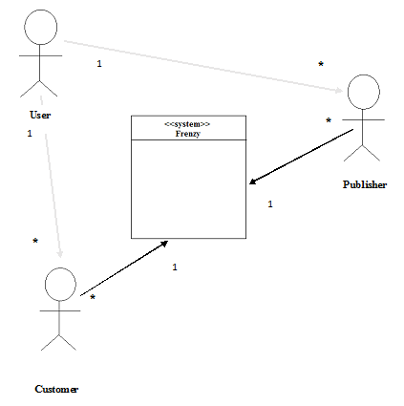

Figure 1: System Context Diagram

| **Actor** | **Description** | **Responsibilities** |
| --- | --- | --- |
| User | User of frenzy. | The users of frenzy can be either customers who can shop for products or publishers who can publish articles to the frenzy website |
| Customer | Frenzy’s customers/ shoppers | Shhop for products, choosing similar products of a brand/ lower prices |
| Publishers | The people who publish articles in frenzy | Publish articles and monetize product sales on frenzy |

Table 1: Actors Summary

##### Artifacts & Information

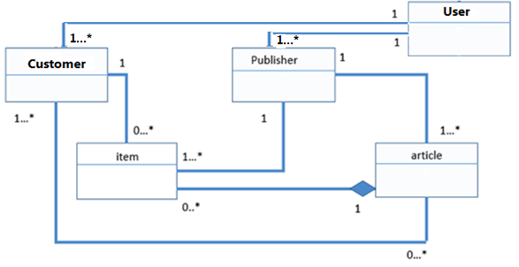Figure 2: Artifacts and Information Diagram

Table 2: Artifacts and Information Summary

|  |  |
| --- | --- |
| **Artifact** | **Purpose** |
| User | Contains user profile information and history |
| Customer | Contains information about products purchased, clipped products, articles followed |
| Publisher | Contains profile information about publisher, published articles |
| Article | Contains article content, author of article and tags associated with it |
| Item | Contains item details like price of item, tags associated with it, description, buy an clip functionalities |

##### Behavior

Below you can see the process diagram (use case diagram). In the next sections we are going to describe some of the use cases.

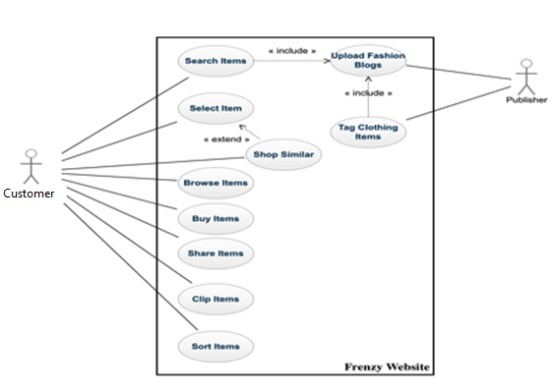Figure 3: Process Diagram

##### Process Descriptions: Shop Widget, Shop Similar, Clothing Tags

Table 3: Process Description: Shop Widget

|  |  |
| --- | --- |
| **Identifier** | UC-2: Select Item |
| **Purpose** | Allow user to shop for products or clip a particular product for future use |
| **Requirements** | WC_4239 |
| **Development Risks** | None |
| **Pre-conditions** | User is logged in the system. |
| **Post-conditions** | User buys/clips an item |

Table 4: Process Description: Shop Similar

|  |  |
| --- | --- |
| **Identifier** | UC-3: Shop similar products |
| **Purpose** | Allow user to shop for products similar to the selected product based on price, category or brand |
| **Requirements** | WC_4238 |
| **Development Risks** | None |
| **Pre-conditions** | User logged in and shop widget is functioning appropriately |
| **Post-conditions** | User shops for similar priced product or a product of similar brand |

Table 5: Process Description: Clothing Tags

|  |  |
| --- | --- |
| **Identifier** | UC-4: Clothing tags of a product |
| **Purpose** | When an article is published, the items in the article are associated with tags and the user can look at the tags aand purchase the product |
| **Requirements** | WC_4241 |
| **Development Risks** | None |
| **Pre-conditions** | User logged in and shop widget is functioning appropriately |
| **Post-conditions** | User looks at tags and purchases/clips product |

Table 6: Typical Course of Action- Shop Widget

|  |  |  |
| --- | --- | --- |
| **Seq#** | **Actor’s Action** | **System’s Response** |
| **1** | User clicks on the Shop button |  |
| **2** |  | System shows the shop widget to view the product |
| **3** | User clicks on the left/right scroll buttons |  |
| **4** |  | System gives more products on the next window |
| **5** | User clicks on ‘Save’ button |  |
| **6** |  | System adds the picture to ‘Recently added’ section |
| **7** | User clicks on ‘Buy’ button |  |
| **8** |  | System redirects to retailer website to help him buy the product |
| **9** | User clicks on high to low or low to high, new arrival checkbox |  |
|  |  | System sorts the product based on price in ascending or descending order/ new arrivals |

Table 7: Alternate Course of Action- Shop similar products

|  |  |  |
| --- | --- | --- |
| **Seq#** | **Actor’s Action** | **System’s Response** |
| **1** | User chooses shop similar button |  |
| **2** |  | System opens shop widget with additional shop similar functionality |
| **3** | User clicks on lower prices |  |
| **4** |  | System finds out products cheaper than the current product |
| **5** | User clicks on ‘Similar Items’ button |  |
| **6** |  | System finds out products with same color, category as the selected product |
| **7** | User clicks on ‘Same Brand’ button |  |
| **8** |  | System finds out products with same brand and as the selected product |
| **9** | User clicks on high to low or low to high checkbox |  |
|  |  | System sorts the product based on price in ascending or descending order |

##### Top Level Physical and Logical Architecture

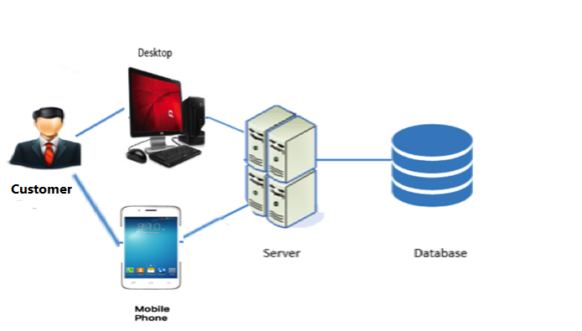

**Figure 4: Top Level Physical Architecture**



**Figure 5: Top Level Logical Architecture**

##### Modes of Operation

The Frenzy System will not have multiple modes and operate in only one mode, so that no further description is required.

#### System Analysis Rationale

The part of Frenzy Web app that needs to be designed, aims to make user experience robust and search results efficient. The application mainly targets people on the age range of 18-45. The two main functions are shop widgets and shop similar.

The first function will provide the user with an additional functionality of shop similar. It will also make amendments in the product slide view. It also aims to show sorting options on the top of the widget layer for better user experience.

The second function is to provide user with the ability to search large collection of products efficiently by sorting by prices (high to low and low to high), new arrivals, showing lower end products, showing product of the same brands and showing similar products (showing products of the same color id, category as the selected product). This function makes the search results relevant to the user’s liking.